1.
Tags <!Doctype>
Tiek izmantots lai patiekt programmai prieksa ar ko vina darbosies jeb define dokumentu tipu
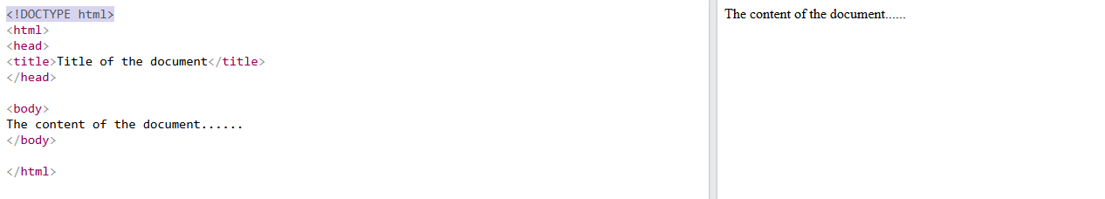
2. Tags <a>
Izmanto lai pievieno hyperlink kas aizved uz citu majaslapu vai vietu
<!DOCTYPE html>
<html>
<body>

<h1>The a element</h1>

<a href="https://www.w3schools.com">Visit W3Schools.com!</a>

</body>
</html>
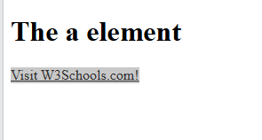
3. Tags <b>
Izmanto lai padaritu tekstu par treknrakstu
<!DOCTYPE html>
<html>
<body>

<h1>The b element</h1>

<p>This is normal text - <b>and this is bold text</b>.</p>

</body>
</html>
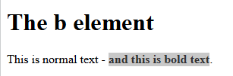
4.Tags <!--…-->
Izmanto lai koda ievietotu komentaru
<!DOCTYPE html>
<html>
<body>

<!-- This is a comment --> seit ir komentars
<p>This is a paragraph.</p>
<!-- Comments are not displayed in the browser --> Seit ari ir komentars

</body>
</html>
5. Tags <body>
Izmanto lai veidot majaslapai kermeni
<html>
<head>
<title>Title of the document</title>
</head>
// sakot no sejiens
<body>
<h1>This is a heading</h1>
<p>This is a paragraph.</p>
</body>
// biedzot ar sejieni beidzas majaslapas kermenis
</html>
6.tags <br>
Tas ir taka kad ievada tekstu un kad beigas ir <br> viņš izpilda Enter funkciju un nakosais teksts bus jauna rinda
<!DOCTYPE html>
<html>
<body>

<h1>The br element</h1>

<p>To force<br> line breaks<br> in a text,<br> use the br<br> element.</p>

</body>
</html>
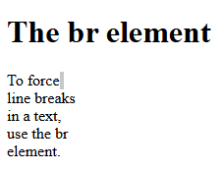
7.Tags <button>
Izveido interaktivo bloku ar ko var iedarboties
<!DOCTYPE html>
<html>
<body>

<h1>The button Element</h1>

<button type="button" onclick="alert('Hello world!')">Click Me!</button>

</body>
</html>
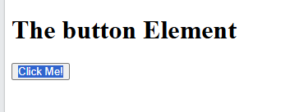
8.Tags <h1> līdz <h6>
Tas ir virsraksta fonta lielums
<!DOCTYPE html>
<html>
<body>

<h1>This is heading 1</h1>
<h2>This is heading 2</h2>
<h3>This is heading 3</h3>
<h4>This is heading 4</h4>
<h5>This is heading 5</h5>
<h6>This is heading 6</h6>

<p><b>Tip:</b> Use h1 to h6 elements only for headings. Do not use them just to make text bold or big. Use other tags for that.</p>

</body>
</html>
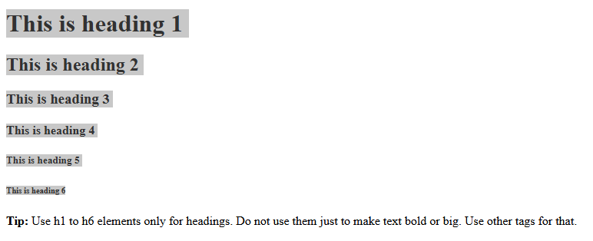
9. Tags <Head>
Tas ir galvene majaslapas jeb viss tas kas augsa virs search bar
<!DOCTYPE html>
<html lang="en">
<head>
<title>Title of the document</title>
</head>
<body>

<h1>This is a heading</h1>
<p>This is a paragraph.</p>

</body>
</html>
10. Tags <img>
Izmanto lai ievietotu attelu majaslapa vai programma
<!DOCTYPE html>
<html>
<body>

<h1>The img element</h1>

<img src="img_girl.jpg" alt="Girl in a jacket" width="500" height="600">

</body>
</html>

11. Tags <link>
Izveido attiecibas starp majaslapam jeb kodiem piem vari css link pievienot savai majaslapai un viņa izmantos to stilu kas ir pievienots no css pec deafult
<!DOCTYPE html>
<html>
<head>
<link rel="stylesheet" href="styles.css">
</head>
<body>

<h1>Hello World!</h1>

<h2>I am formatted with a linked style sheet.</h2>

<p>Me too!</p>

</body>
</html>
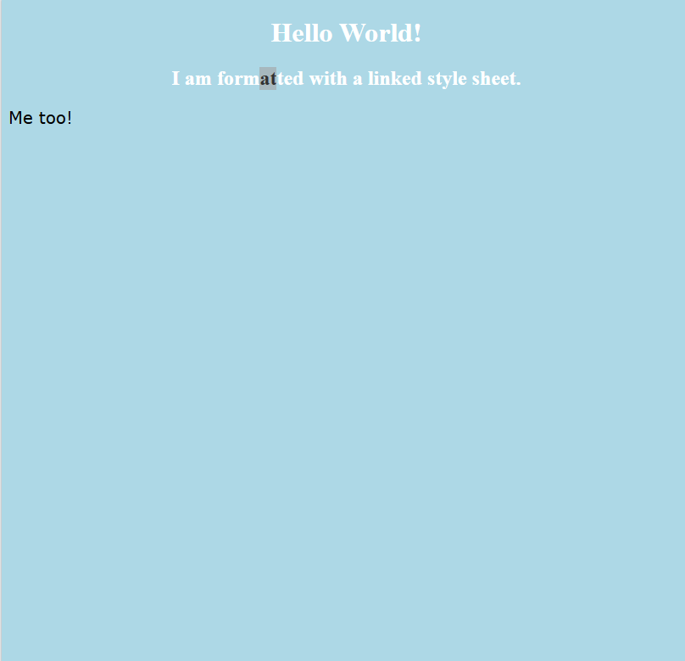
12.Tags <ol>
Izmanto lai taisitu secigu numuracijas sarkastu
<!DOCTYPE html>
<html>
<body>

<h1>The ol element</h1>

<ol>
<li>Gulta</li>
<li>Maize</li>
<li>teja</li>
</ol>

</body>
</html>
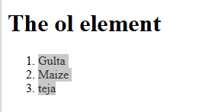
13.Tags <p>
Izmanto lai ievietotu parastu tekstu
<!DOCTYPE html>
<html>
<body>

<h1>The p element</h1>

<p>Man patik programmet</p>
<p>Man patik spelet :D</p>

</body>
</html>
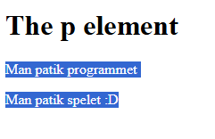
14.Tags <section>
Define majaslapai sekciju un taja sekcija ir ietilpst kāds kods un pec tam var pievienot hyperlink to sekciju un viņa aizved pie noteiktas lapas dalas
<!DOCTYPE html>
<html>
<body>

<h1>The section element</h1>

<section>
<h2>Skola</h2>
<p>Macos gulu un vel reiz macos.</p>
</section>

<section>
<h2>Maja</h2>
<p>Gulu speleju un edu.</p>
</section>

</body>
</html>
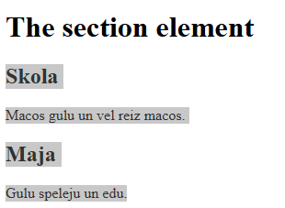
15.Tags <table>
Izmanto lai izvedotu tabulu
<!DOCTYPE html>
<html>
<head>
<style>
table, th, td {
border: 1px solid black;
}
</style>
</head>
<body>

<h1>The table element</h1>

<table>

</table>

</body>
</html>
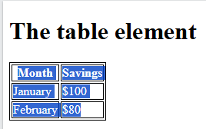
16.Tags <ul>
Veido ne kartotu sarakstu vai ne numuretu
<!DOCTYPE html>
<html>
<body>

<h1>The ul element</h1>

<ul>
<li>KFC</li>
<li>Teja</li>
<li>Maja</li>
</ul>

</body>
</html>
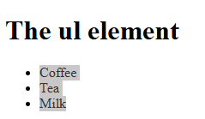
17. Tags <td>
Veido tabulas rindu jeb sunu
<!DOCTYPE html>
<html>
<head>
<style>
table, th, td {
border: 1px solid black;
}
</style>
</head>
<body>

<h1>The td element</h1>

<p>The td element defines a cell in a table:</p>

<table>
<tr>
<td>Cell A</td>
<td>Cell B</td>
<td>Cell C</td>
<td>Cell D</td>

</tr>
</table>

</body>
</html>
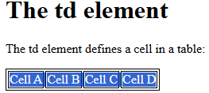
18.Tags <tr>
Veido tabulas kolonu
<!DOCTYPE html>
<html>
<head>
<style>
table, th, td {
border: 1px solid black;
}
</style>
</head>
<body>

<h1>The td element</h1>

<p>The td element defines a cell in a table:</p>

<table>
<tr>
<td>Cell A</td>

</tr>
<tr>
<td>Cell B</td>
<td>Cell C</td>
<td>Cell D</td>
</tr>
</table>

</body>
</html>
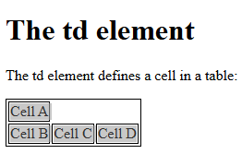
19 Tags <title>
Veido augsa majaslapas nosaukumu augsa virs searchbar
<!DOCTYPE html>
<html lang="en">
<head>
<title>Majaslapas virspuses nosaukums</title>
</head>
<body>

<h1>This is a heading</h1>
<p>This is a paragraph.</p>

</body>
</html>

20. Tags <small>
Izmanto lai padaritu tekstu mazaku
<!DOCTYPE html>
<html>
<body>

<h1>The small element</h1>

<p>Normals tekst.</p>
<p><small>Tas pats tekst bet mazaks.</small></p>

</body>
</html>
