<a>
Birka <a>definē hipersaiti, ko izmanto, lai izveidotu saiti no vienas lapas uz citu.
<a> LĪNIJAS elements
ATRIBUTI:
download
href
hreflang
media
ping
referrerpolicy
rel
target
type

<!DOCTYPE html>
<html>
<body>

<h1>The a element</h1>

<a href="https://www.google.com/">google!</a>

</body>
</html>
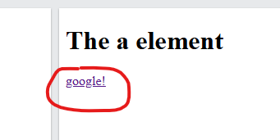
<abbr>
Birka <abbr>definē saīsinājumu vai akronīmu, piemēram, "HTML", "CSS", "Mr.", "Dr.", "ASAP", "ATM".
<abbr> LĪNIJAS elements
ATRIBUTI: NAV

<!DOCTYPE html>
<html>
<body>

<h1>The abbr element</h1>

<p>The <abbr title="World Health Organization">HIIII</abbr> was founded in 1948.</p>

</body>
</html>
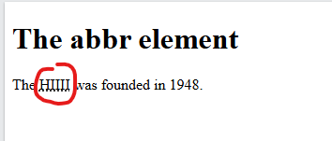
<address>
Birka <address>definē dokumenta vai raksta autora/īpašnieka kontaktinformāciju.
<address> bloka elements
ATRIBUTI: NAV

<!DOCTYPE html>
<html>
<body>

<h1>The address element</h1>

<address>
Written by <a href="mailto:webmaster@example.com">ESMU TE</a>.<br>
Visit us at:<br>
Example.com<br>
Box 564, Disneyland<br>
USA
</address>

</body>
</html>
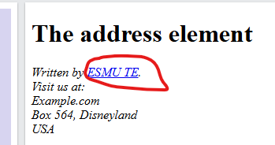

<article>
Birka <article>norāda neatkarīgu, pašpietiekamu saturu.
<article> bloka elements
ATRIBUTI: NAV
<!DOCTYPE html>
<html>
<body>

<h1>The article element</h1>

<article>
<h2>HMM</h2>
<p>Google Chrome is a web browser developed by Google, released in 2008. Chrome is the world's most popular web browser today!</p>
</article>

<article>
<h2>HMM</h2>
<p>Mozilla Firefox is an open-source web browser developed by Mozilla. Firefox has been the second most popular web browser since January, 2018.</p>
</article>

<article>
<h2>HMM</h2>
<p>Microsoft Edge is a web browser developed by Microsoft, released in 2015. Microsoft Edge replaced Internet Explorer.</p>
</article>

</body>
</html>
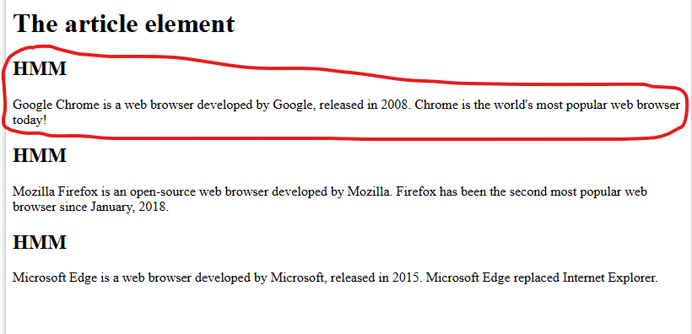
<aside>
Birka <aside>definē arī citu saturu, ne tikai to, kurā tā tiek ievietota.
<aside> bloka elements
ATRIBUTI: NAV
<!DOCTYPE html>
<html>
<body>

<h1>The aside element</h1>

<p>My family and I visited The Epcot center this summer. The weather was nice, and Epcot was amazing! I had a great summer together with my family!</p>

<aside>
<h4>HMMHMMHMM</h4>
<p>Epcot is a theme park at Walt Disney World Resort featuring exciting attractions, international pavilions, award-winning fireworks and seasonal special events.</p>
</aside>

</body>
</html>
